Quality Management Activities
Quality Management
Software quality management can be structured into three principal activities:
Quality assurance - The establishment of a framework of organizational procedures and standards which lead to high quality software.
Quality planning – The selection of appropriate procedures and standards from this framework and adaptation of these for a specific software project.
Quality control – The definition and enactment of processes which ensure that the project quality procedures and standards are followed by the software development team.
Software Quality Management
• Quality management provides an independent check on the software development process. The deliverables from the software process are input to the quality management process and are checked to ensure that they are consistent with organizational standards and goals.
• Quality management should be separated from project management so that quality is not compromised by management responsibilities for project budget and schedule. An independent team should responsible for quality management and should report to the management above the project management level.
• There must be a management commitment to quality.
Software Quality Management
• Concerned with ensuring that the required level of quality is achieved in a software product.
• Involves defining appropriate quality standards and procedures and ensuring that these are followed.
• Should aim to develop a ‘quality culture’ where quality is seen as everyone’s responsibility.
What is Quality?
• Quality, simplistically, means that a product should meet its specification.
• This is problematical for software systems
– There is a tension between customer quality requirements (efficiency, reliability, etc.) and developer quality requirements (maintainability, reusability, etc.)
– Some quality requirements are difficult to specify in an unambiguous way.
– Software specifications are usually incomplete and often inconsistent.
Traditional view - quality is about perfection/bug free code. Generally associated with testing at the end of development.
Testing cannot introduce quality to a product; it can only reduce the number of defects in the product.
Modern view (ISO 9000) – Good quality is not perfection but fit for the purpose. Build the right product in the right way. Do not over engineer (too expensive). Do not under engineer (not fit for the purpose).
Scope of Quality Management
• Quality management is particularly important for large, complex systems. The quality documentation is a record of progress and supports continuity of development as the development team changes.
• For smaller systems, quality management needs less documentation and should focus on establishing a quality culture.
Quality Management Activities
• Quality assurance
– Establish organizational procedures and standards for quality.
• Quality planning
– Select applicable procedures and standards for a particular project and modify these as required.
• Quality control
– Ensure that procedures and standards are followed by the software development team.
Quality management should be separate from project management to ensure independence.
Quality Management and Software Development
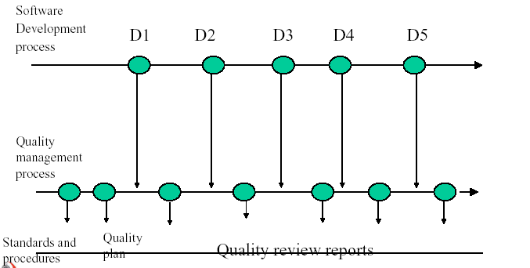

9.2. Product and Process Quality
Process and Product Quality
• The quality of a developed product is influenced by the quality of the production process.
• This is important in software development as some product quality attributes are hard to assess.
• However, there is a very complex and poorly understood relationship between software processes and product quality.
Process-based Quality
• There is a straightforward link between process and product in manufactured goods.
• More complex for software because:
– The application of individual skills and experience is particularly important in software development;
– External factors such as the novelty of an application or the need for an accelerated development schedule may impair product quality.
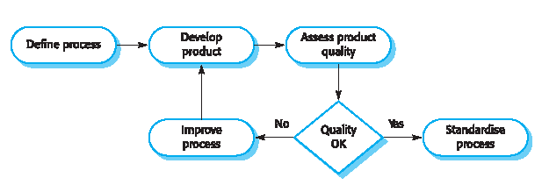
• Care must be taken not to impose inappropriate process standards - these could reduce rather than improve the product quality.
Process-based Quality

Practical Process Quality
• Define process standards such as how reviews should be conducted, configuration management, etc.
• Monitor the development process to ensure that standards are being followed.
• Report on the process to project management and software procurer.
• Don’t use inappropriate practices simply because standards have been established.
9.3. Standards
Quality Assurance and Standards
Quality assurance (QA) activities define a framework for achieving software quality.
There are two types of standards that may be established as a part of the quality assurance process:
Product standards – These are standards that apply to the software product being developed. They include standards such as document standards (eg. Specification of a class), coding standards and user interface standards. Product quality includes reusability, usability, portability, maintainability etc.
Process standards –These are standards that define the processes which should be followed during software development. They may include definitions of specification, design and validation processes and a description of the documents which must be generated in the course of these processes.
Importance of Standards
• Encapsulation of best practice
-avoids repetition of past mistakes.
• They are a framework for quality assurance processes
-they involve checking compliance to standards.
• They provide continuity
- New staff can understand the organization by understanding the standards that are used.
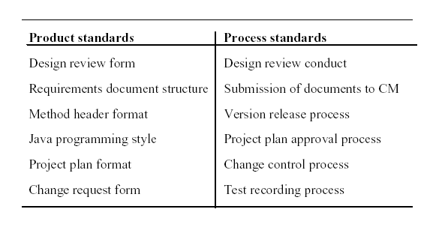
Product and Process Standards

Problems with Standards
• They may not be seen as relevant and up-to-date by software engineers.
• They often involve too much bureaucratic form filling.
• If they are unsupported by software tools, tedious manual work is often involved to maintain the documentation associated with the standards.
ISO9000
• ISO9000 is a set of international standards that can be applied to a range of organisations from manufacturing through to service industries.
• ISO9001 is the most general of these standards and applies to organisations concerned with quality processes regarding design, development and maintain products. This is a generic model of a quality process which describes various aspects of that process and defines which standards and procedures could exist within an organisation.
• ISO 9000-3 interprets ISO 9000 for software development.
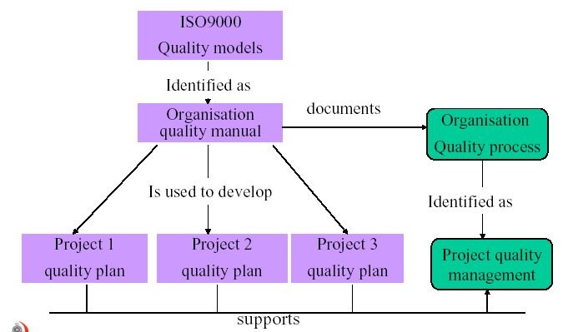
ISO9000 and Quality Management

ISO900-1 is a general guideline which gives background information about the family of standards.
ISO9002 and ISO9003 are subsets of ISO9001.
ISO9002 is used for situations in which there is no design.
ISO9003 is used for situations in which there is neither design nor production (eg. Retail).
ISO9000-3 is a guideline on how to use ISO9001 for software development.
When asked whether cost, timescale or quality was most important when completing against another company for a software project Tomoo Mastubara of Hitachi Software Engineering replied “Quality is first! Always first. If we deliver bad quality to the customer, the customer will complain many times, over and over. But if we are late, he will complain only once and then may be he will forget. And if we have underestimated the cost, the customer will not complain at all. – for he will know we have made the mistake. WE will bear the burden of the cost mistake” Any serious quality initiative will repay any set-up costs within the first years through improved productivity and customer satisfaction.
Documentation Standards
• Documentation standards in a software project are particularly important as documents are the only tangible way of representing the software and the software process.
• There are three types of documentation standards
– Documentation Process Standards
Define the process which should be followed for document production.
– Document Standards
Govern the structure and presentation of documents.
– Document Interchange Standards
Ensure that all electronic copies of documents are compatible.
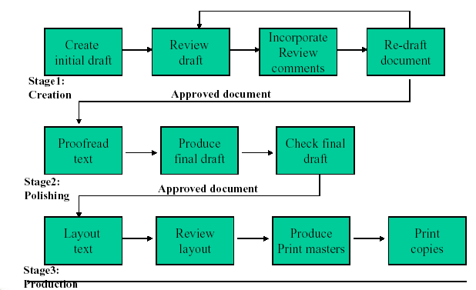
A document production process including quality checks

Capability Maturity Model (CMM)
• CMM was developed at the Software Engineering Institute (SEI) in Pittsburgh, and it is very much a rival to ISO9001
for software.
• Is a scheme to classify a software development organization according to its capability. CMM identifies five different
maturity levels for software developing organizations.
1. Initial-The software development is run informally, and depends on the competence of some persons.
2. Repeatable-There is a common system for project management and control.
3. Defined-There is a common system for the software engineering activities.
4. Managed-The software development process is stable and gives a consistent product quality. Measurements are used
to keep the process and product under control.
5. Optimizing-The software development process contain its own improvement process. Process improvement is
budgeted and planned and is an integral part of the organization’s process.

